MediAssist AI
Multi-Agent Hospital AI System

1. Landing Page — MediAssist AI Frontend
The Streamlit-based landing page for MediAssist AI, showing document and image upload options.
Backend and database connection status are displayed live to confirm system health before use.

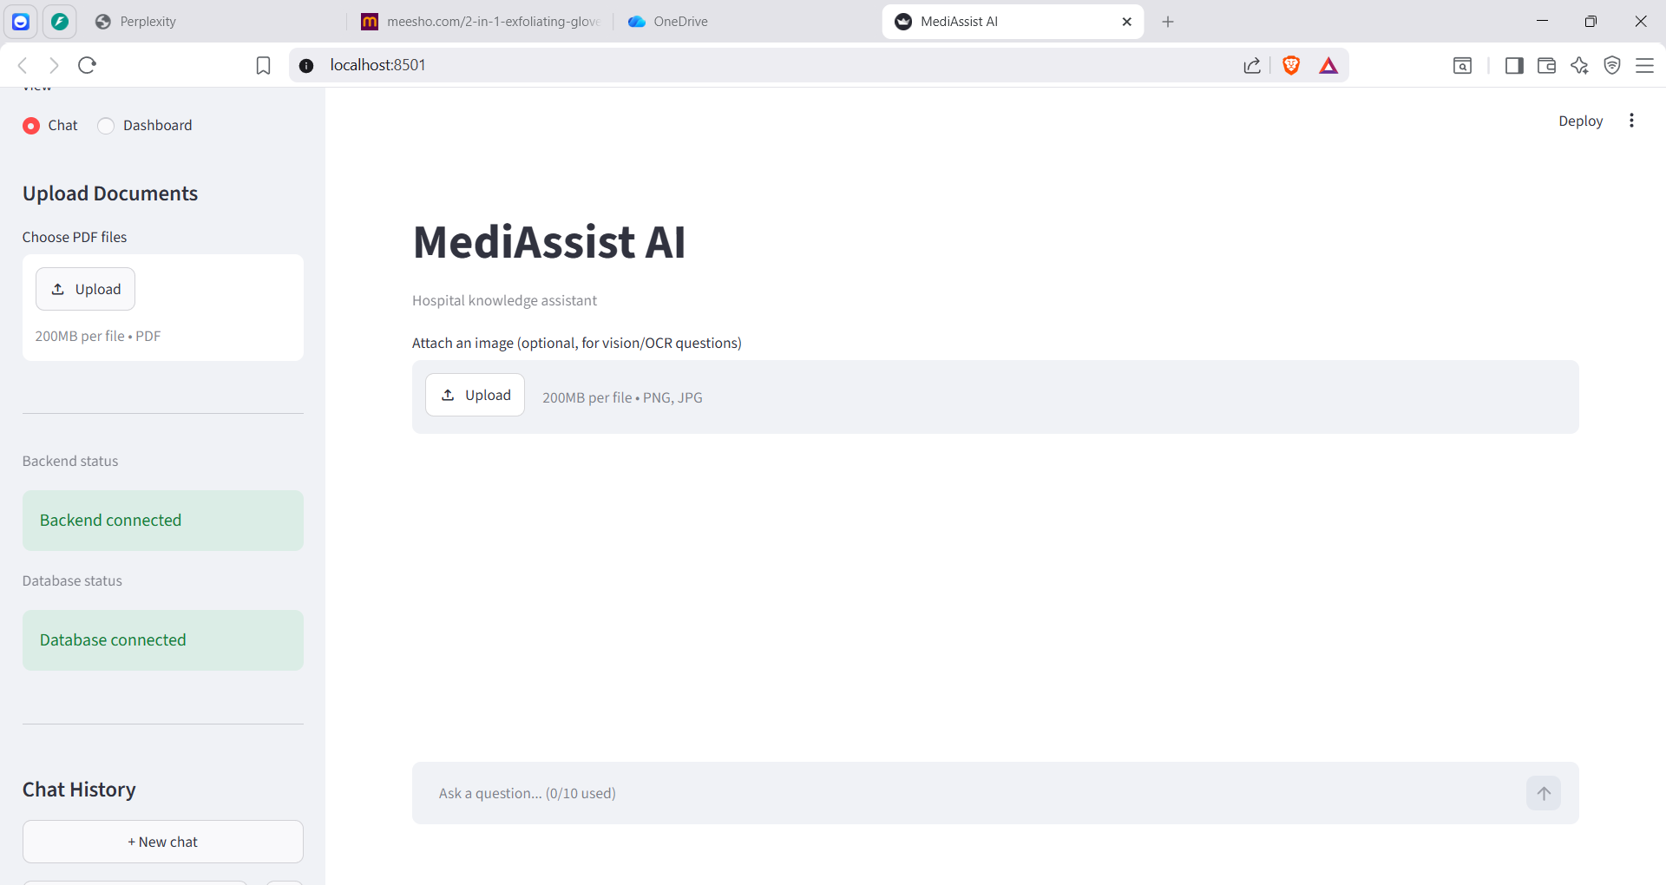

Fig 1. MediAssist AI landing page with upload panel and live status indicators.

2. Conversational Q&A — Patient Rights Query
The RAG-powered chat interface answering a policy question using uploaded hospital SOP documents.
Responses cite exact source PDFs (Admission Process-SOP, Hospital Compliance) for traceability.

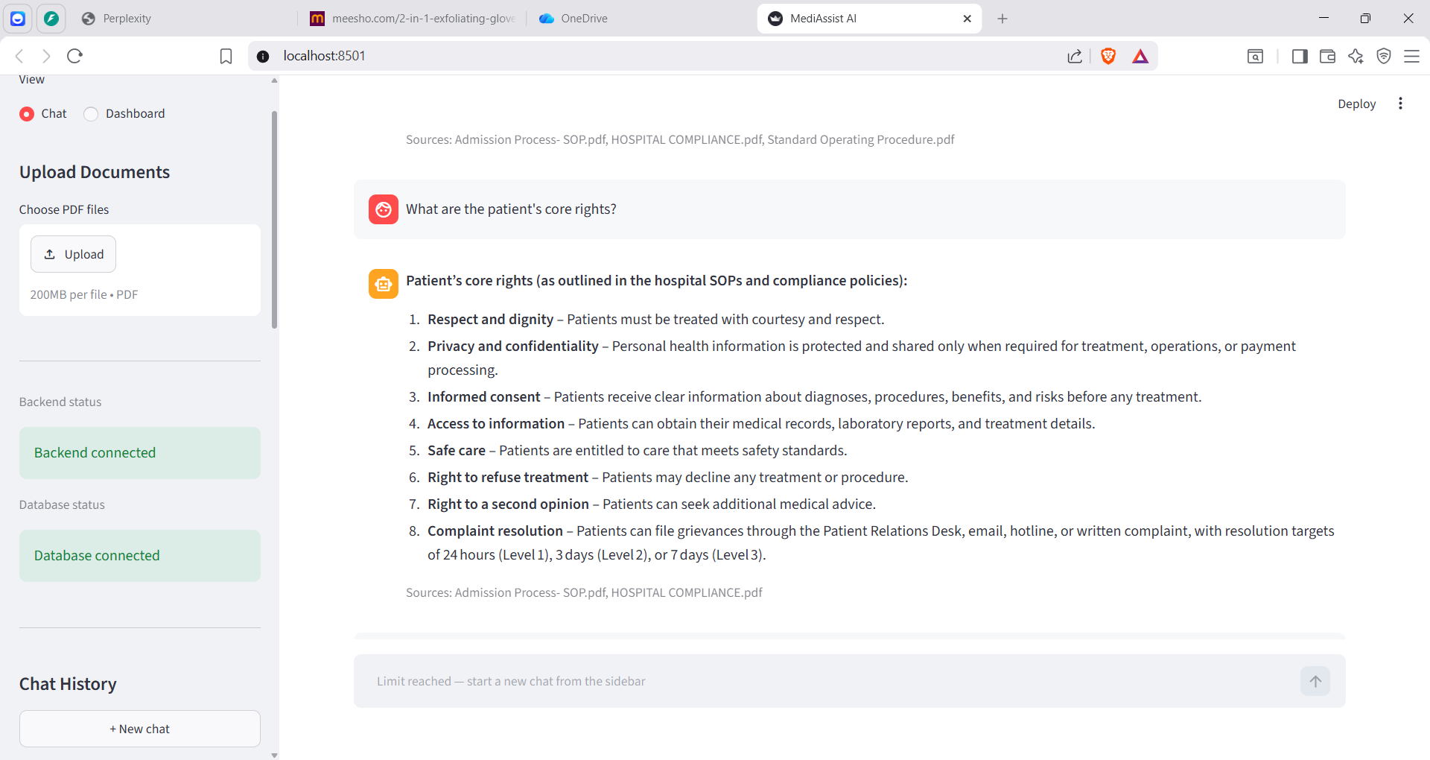

Fig 2. Chat agent answering a patient-rights query with cited source documents.

3. OCR & Vision Agent — Prescription Reading
The multimodal agent extracting structured data from a handwritten prescription image.
It identifies medications, dosages, doctor details, and refill information automatically.

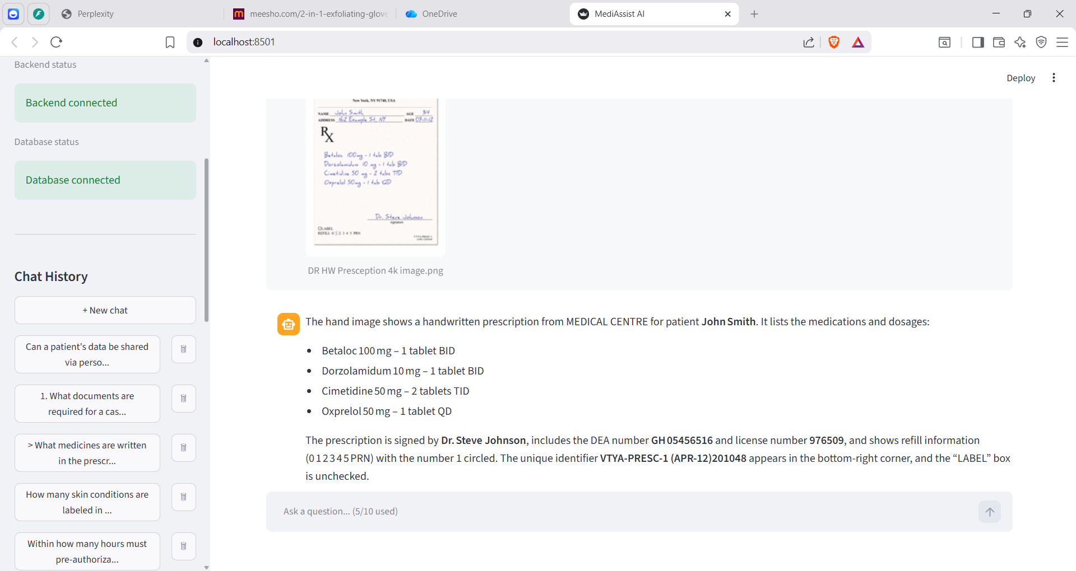
Fig 3. Vision/OCR agent reading and structuring a handwritten prescription.

4. Backend API Documentation
FastAPI's auto-generated interactive docs, listing all backend endpoints for MediAssist AI.
Includes routes for document upload, retrieval, image analysis, prescription OCR, and chat.

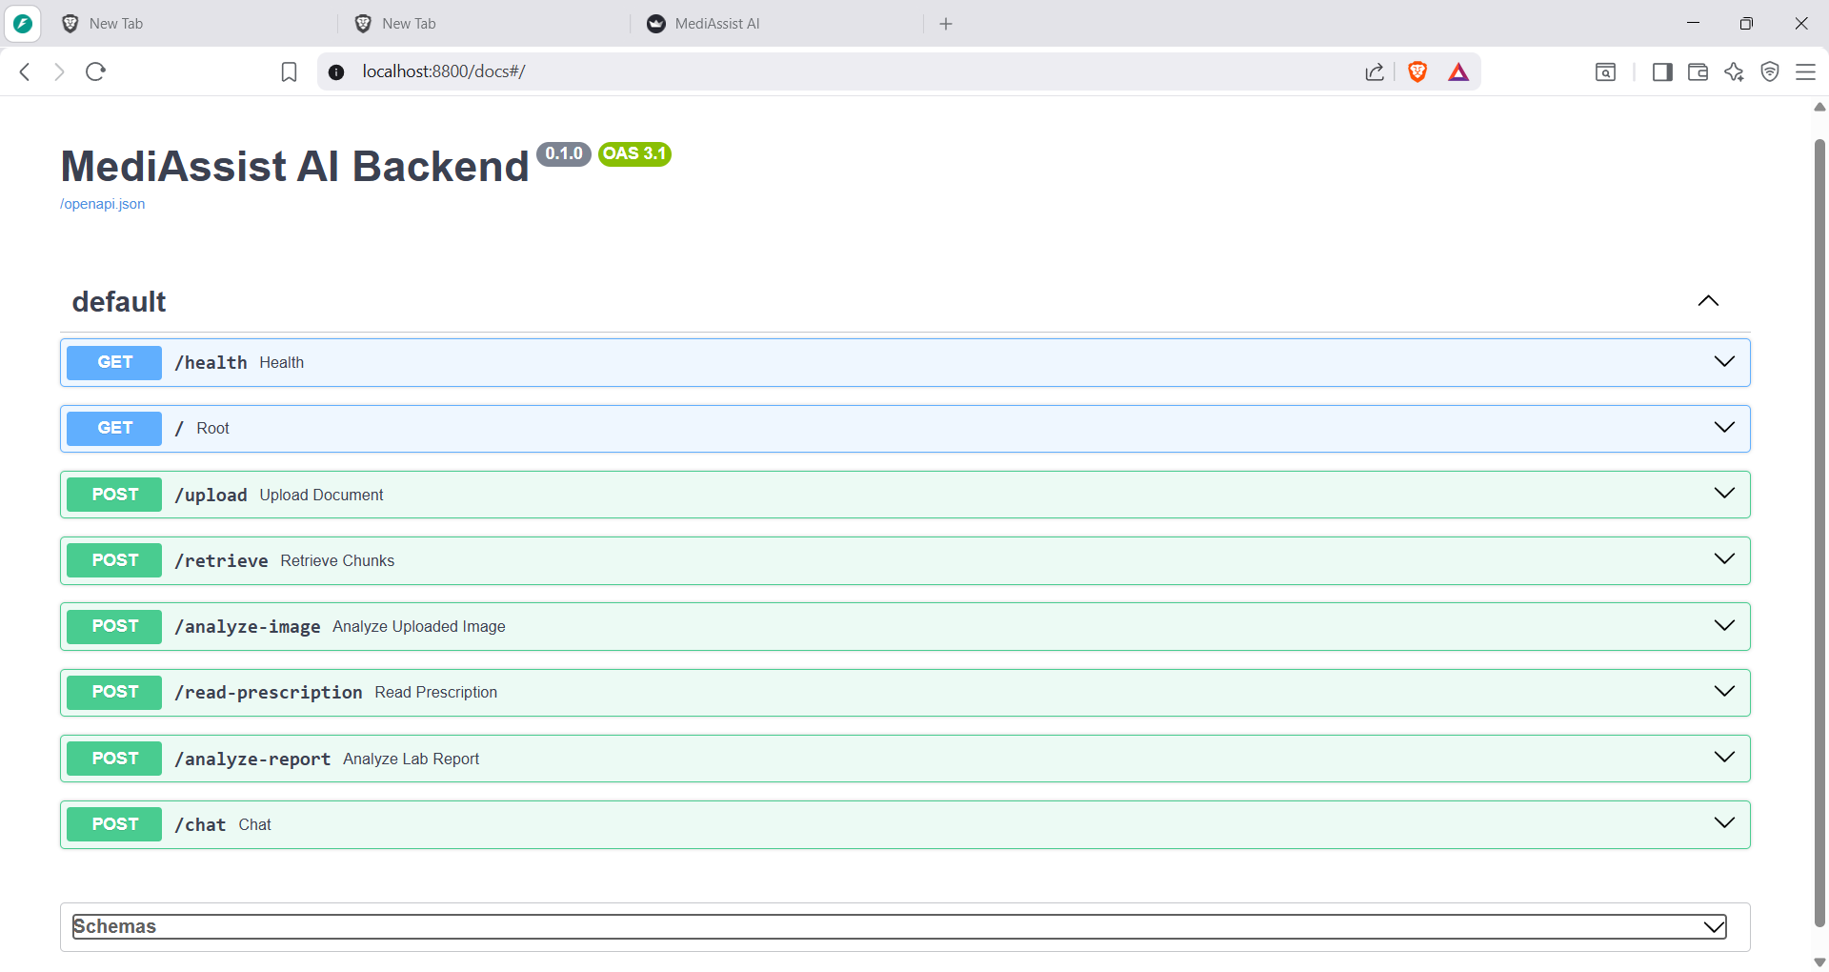
Fig 4. FastAPI backend documentation (OpenAPI) at localhost:8800/docs.

5. Docker Images — Backend and Frontend
Docker Desktop showing the two built images: medassist_ai-backend and medassist_ai-frontend.
Confirms both services were successfully containerized and are ready to run.

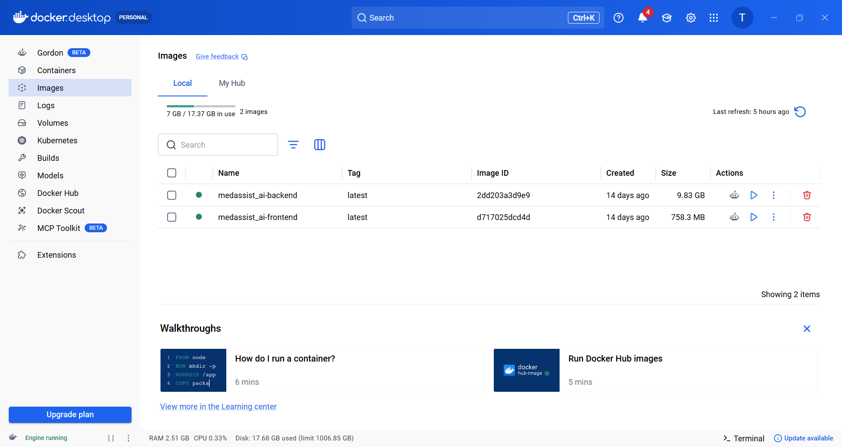

Fig 5. Local Docker images for the backend and frontend services.

6. Docker Build History
Build history log showing successful and iterative builds for both frontend and backend images.
Reflects the debugging and optimization cycle carried out during containerization.

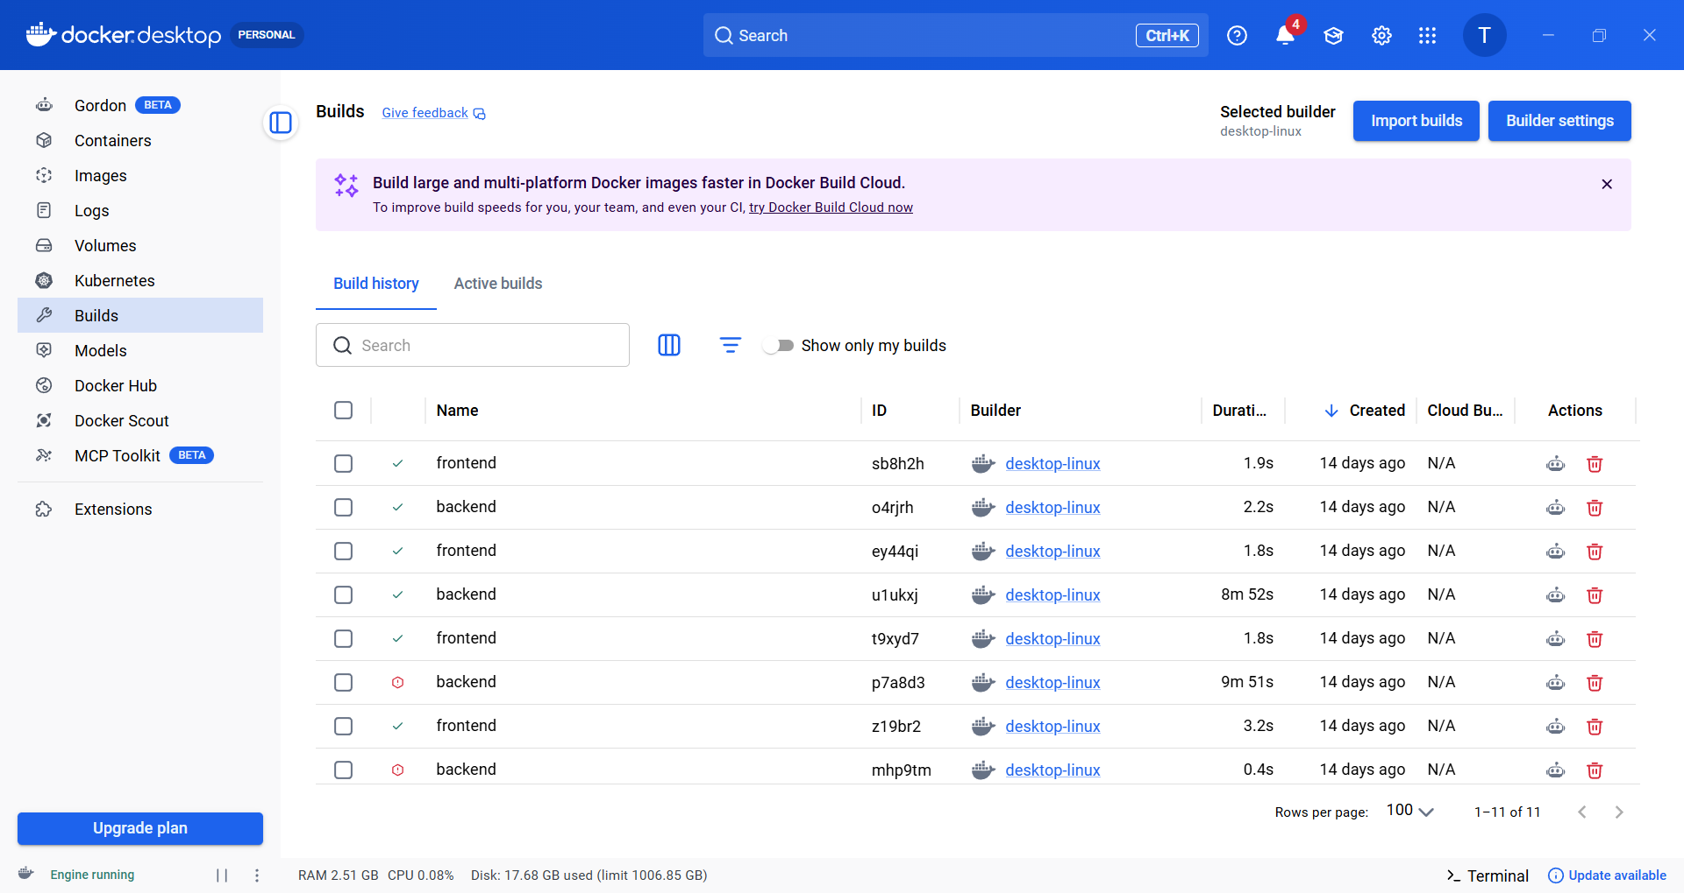

Fig 6. Build history for backend and frontend Docker images.

7. Docker Runtime Logs
Live container logs confirming the Streamlit frontend and FastAPI backend started without errors.
Backend shows successful startup and health-check requests being served correctly.

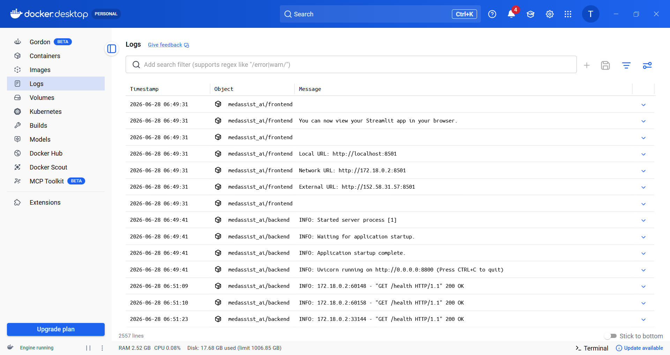
Fig 7. Runtime logs for frontend and backend containers.

8. Running Containers — Resource Monitoring
Docker Desktop's container view showing the running MediAssist AI stack with live CPU and memory usage.
Confirms the full application is deployed and stable under normal operating load.
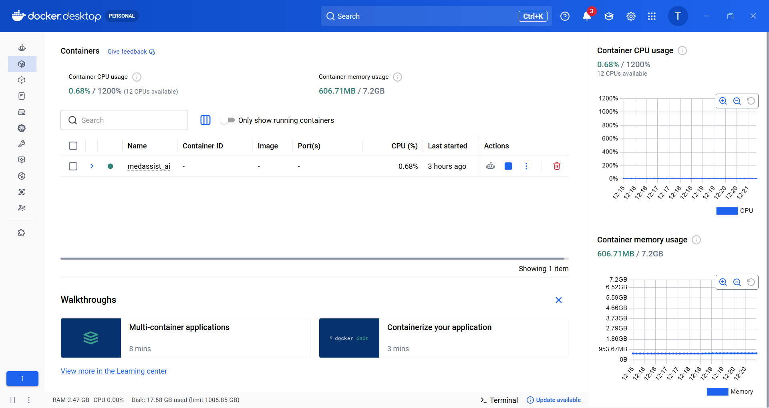

Fig 8. Running container with live CPU and memory monitoring.

9. Activity Dashboard — Overview Metrics
The Streamlit Activity Dashboard summarizing live usage: questions asked, documents uploaded,
images analyzed, prescriptions read, and average response time across the session.

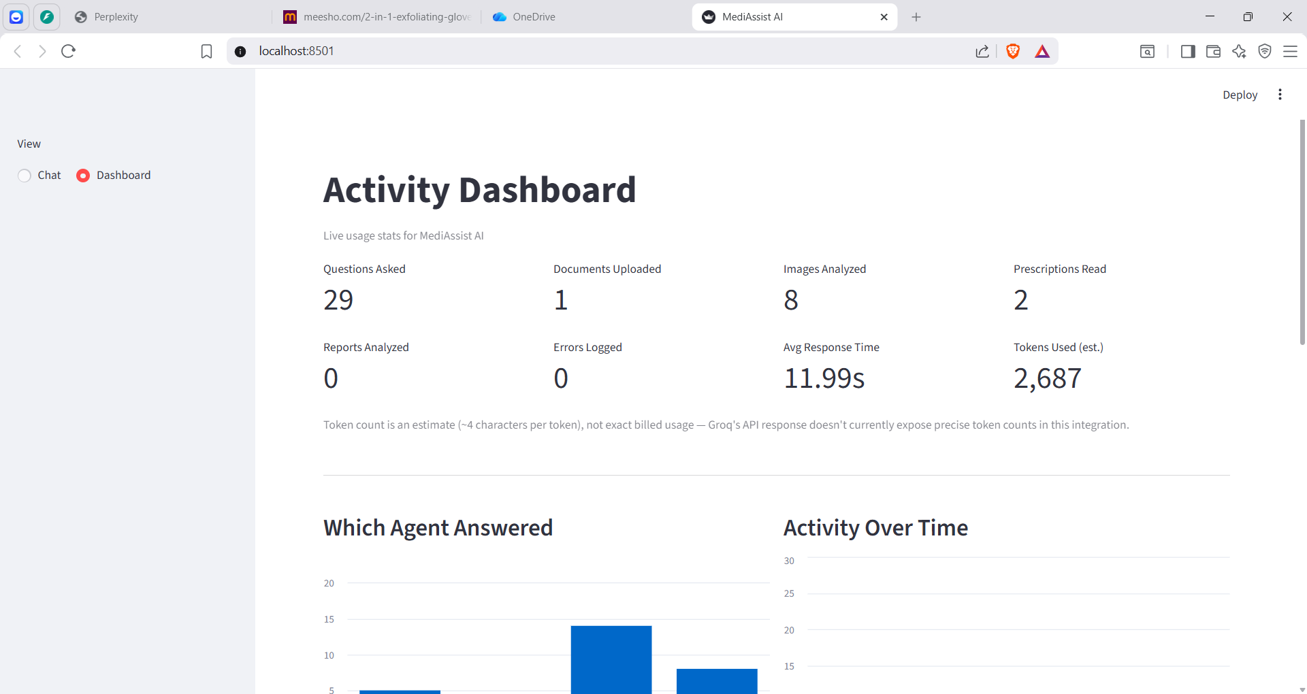
Fig 9. MediAssist AI activity dashboard — key usage metrics.

10. Activity Dashboard — Agent Routing & Trends
Breakdown of which specialized agent (retriever, vision, OCR, or MCP) answered each query.
Includes an activity-over-time chart tracking usage patterns across the day.

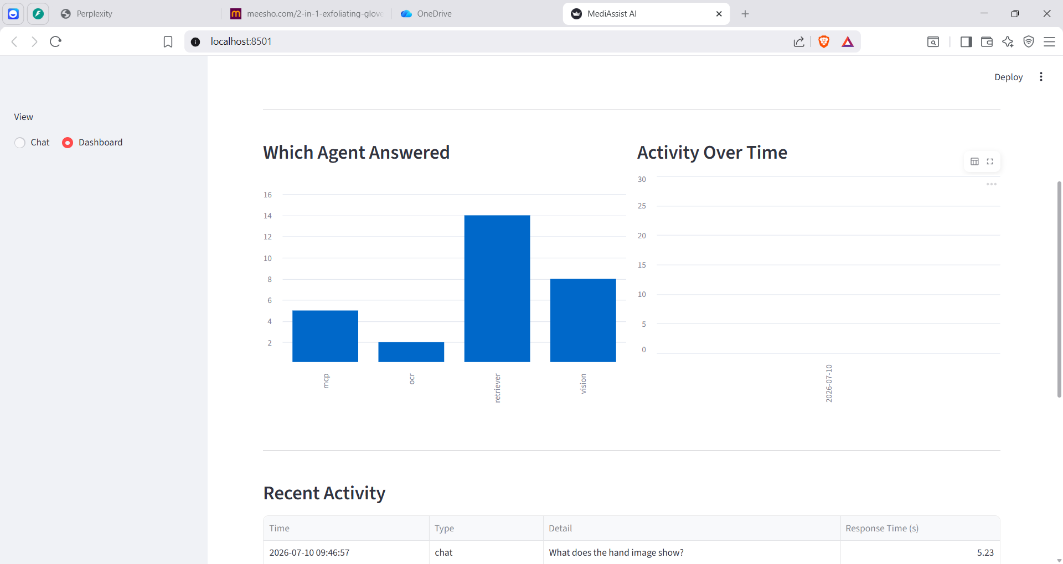

Fig 10. Agent routing distribution and activity trend over time.

11. Activity Dashboard — Recent Activity Log
A detailed, timestamped log of recent chats and uploads, including response time per query.
Provides full transparency into system performance and user interaction history.

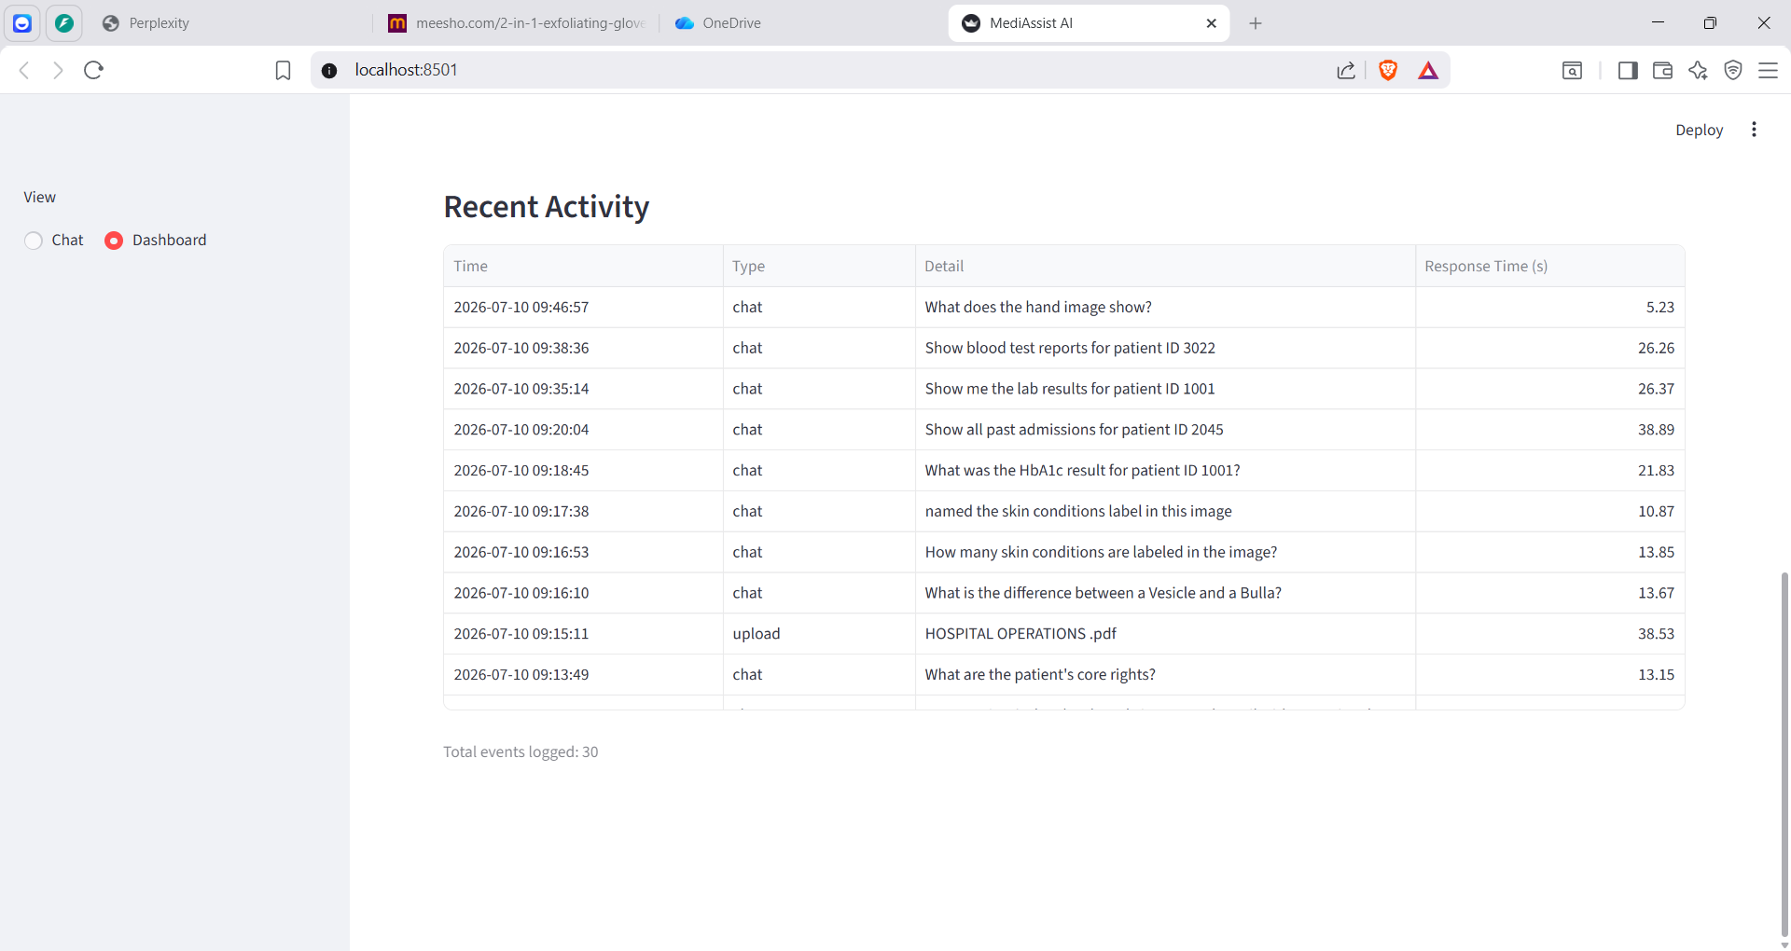

Fig 11. Recent activity log with per-query response times.

